**Banker’s Algorithm**

The Banker's algorithm is run by the operating system whenever a process requests resources.

The algorithm **avoids** deadlock by denying or postponing the request if it determines that accepting the request could put the system in an unsafe state (one where deadlock could occur).

When a new process enters a system, it must declare the maximum number of instances of each resource type that it may ever claim; clearly, that number may not exceed the total number of resources in the system. Also, when a process gets all its requested resources it must return them in a finite amount of time.

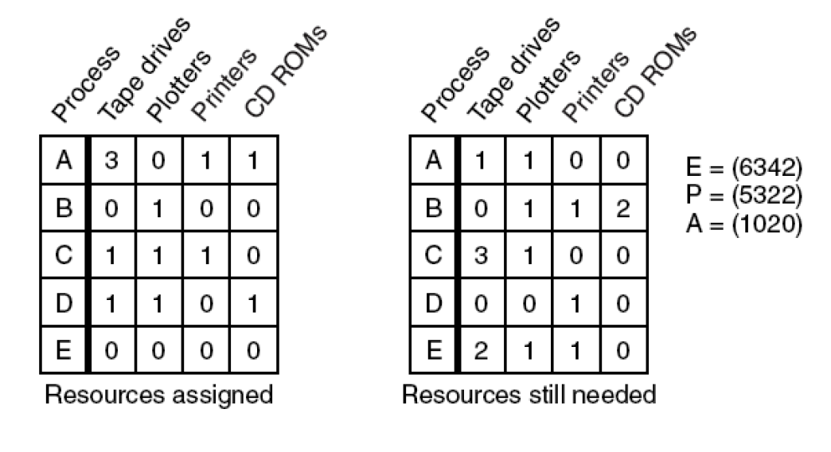

Algorithm for checking to see if a state is safe:

1. Look for row, R, whose unmet resource needs all ≤ A. If no such row exists, system will eventually deadlock since no process can run to completion

2. Assume process of row chosen requests all resources it needs and finishes. Mark process as terminated, add all its resources to the A vector.

3. Repeat steps 1 and 2 until either all processes marked terminated (initial state was safe) or no process left whose resource needs can be met (there is a deadlock).

**IN PUT: // take input from file**

**———————————————————**

**4 // no. of processes**

**5 // no. of resources**

**1 1 2 1 3 // Max. resource Matrix**

**2 2 2 1 0**

**2 1 3 1 0**

**1 1 2 2 1**

**1 0 2 1 1 // Resource allocation Matrix**

**2 0 1 1 0**

**1 1 0 1 0**

**1 1 1 1 0**

**0 0 2 1 2 // resource available**

**OUT PUT:**

**———————————————————**

**Need Matrix :**

**0 1 0 0 2**

**0 2 1 0 0**

**1 0 3 0 0**

**0 0 1 1 1**

**Safe sequence is :**

**D A C B**

**Change in available resource matrix :**

**1 1 3 2 2**

**2 1 5 3 3**

**3 2 5 4 3**

**5 2 6 5 3**